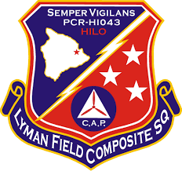
HOW TO ACCESS/RESET PASSWORD TO YOUR HIWGCAP.ORG EMAIL ACCOUNT
Information provided by HIWG-IT
- Log into eServices (capnhq.gov) Note: if you do not remember your password for this, you will need to reset it by clicking the link under “password assistance”.
- Once logged in, click on Menu, Administration, Member Search.
- Type in your CAPID and press enter (Note for Cadets: your information should load automatically)
- Take note of the following: Your rank, town of residence, and your “Original Date Joined.
- Open a new tab and go to “tools.hiwgcap.org”
- Click on Member, Reset Password (You do not have to be logged in to access this function, you wouldn’t be here otherwise)
- Put in your rank, town of residence and your “Original Date Joined”, along with your Last Name, CAPID, and your Wing (Select HIWG from the drop-down menu) Please note that the information you put in has to match exactly from what was provided from eServices.
- Click next and then choose either your Primary or Secondary email address (Note: If your HIWGCAP.ORG email address is listed as your primary email address in eServices, please make sure you have your personal email as your secondary email in eServices so that you can receive the temporary login information.
- Click next and review the information displayed, then click on “Reset Password” You should then receive the email with your HIWGCAP.ORG email address and temporary password.
- Once received, open a new tab and go to “portal.office.com”
- Enter your HIWGCAP.ORG email address and temporary password
- You will then be instructed to change your password (and provide additional information if the system asks you to.)
- You will then see your Office 365 homepage.

THAT’S IT! YOU HAVE SUCUESSFULLY LOGGED INTO YOUR ACCOUNT.

